**Project Charter**

**Castaway (WIP title)**

**2 June 2023**

Fenix Walker and Veer Sanyal

# PROJECT STATEMENT

*Discuss the problem or opportunity that is scheduled for resolution.*

Many people have a lack of knowledge on important survival skills. This choose-your-own-adventure style video game will help teach them how to survive various dangers through encounters and decision-making.

# CONCISE PROJECT OVERVIEW

*A short narrative on the duration, budget, approvals needed, key stakeholders, assumptions, constraints and major risks.*

We will have a little over 20 days to create this project. Everything will be made from free software–namely IntelliJ, GitHub, and JavaFX. We will need approval from our teacher, Mrs. Sakthikumar. The key stakeholders will be Mrs. Sakthikumar and our fellow students who will preview our game after completion. We will assume that people have a device that can run our game.

# SCOPE STATEMENT

*SMART goals or objectives would include deliverables. Clarify as necessary what the scope includes and does not include.*

By June 2, we will complete all aspects of our solution, including documentation, the code, graphics, and 10 or more in-game “encounters”, each with a few options (with consequences) for actions the player can take.

# STAKEHOLDERS

*List all stakeholders, their roles, communication needs and satisfaction requirements.*

* Developers: Fenix Walker and Veer Sanyal (who will be creating the project)
  + Satisfaction requirements:
    - There are a wide variety of encounters
    - In each encounter, the player has options with consequences
    - Teaches the player survival skills
  + Communication needs:
    - We will talk in class and email each other
* Advisor/Client/Teacher: Mrs. Sakthikumar (who will be grading our project)
  + Satisfaction requirements:
    - Must use OOP
    - Must solve a problem in an original and unique way
  + Communication needs:
    - Documentation
    - Asking questions in class
* Other clients: class peers (who will be viewing our project at the end)
  + Satisfaction requirements:
    - Must be engaging
  + Communication needs:
    - Ask feedback in class

# TIMELINE

*Draw a timeline, including milestones to serve as the basis for a work breakdown structure (WBS) and appropriate Gantt or PERT charts. For this class, you can refer to the Work Breakdown Excel Sheet.*

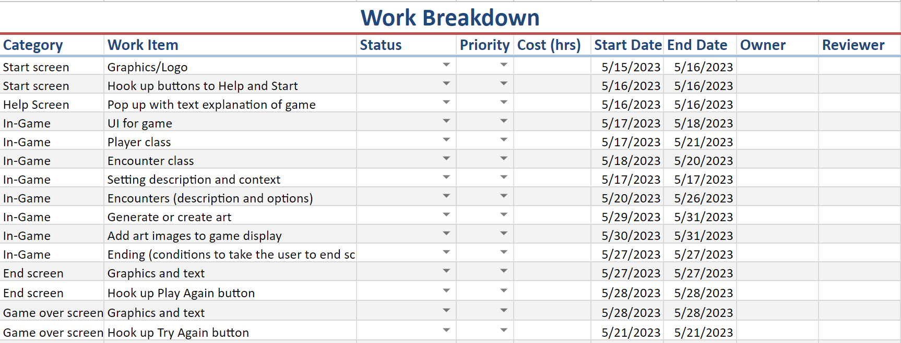

(The Work Breakdown Spreadsheet is saved as an excel file in the Google Drive)

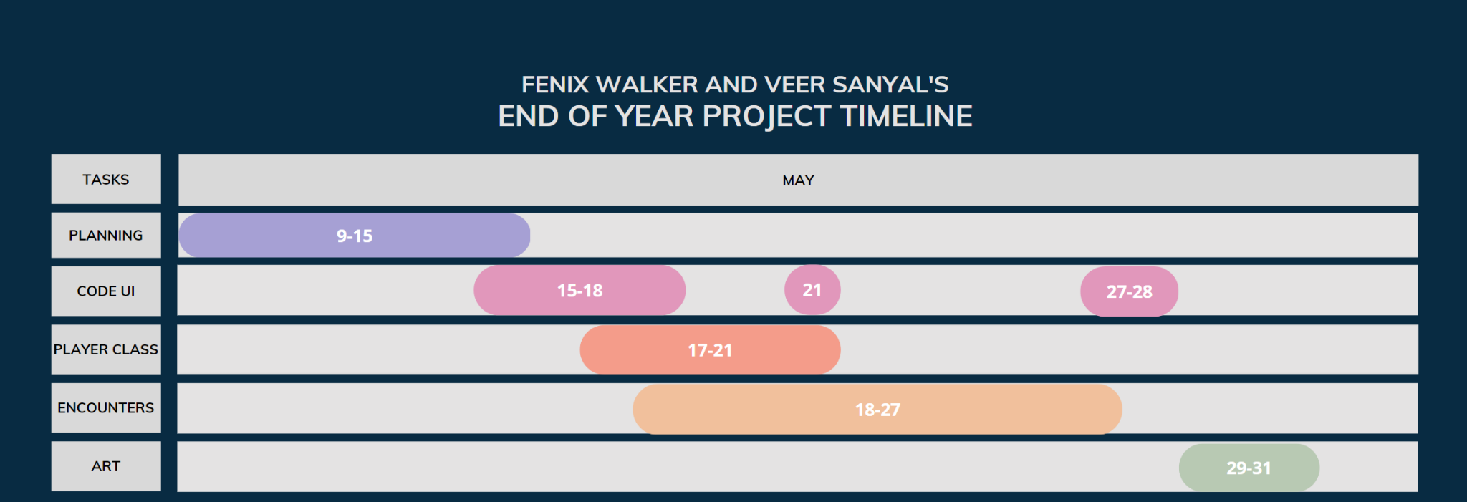

# BUDGET ESTIMATE(S)

*List all costs known and estimated and other resource needs that can be identified. For this project, you can list the time available until the due date, and the people and resources (classroom computers in this case) to get the project done.*

The resources required for this project are classroom computers, and the softwares we are using are GitHub, JavaFX, IntelliJ, and gmail. The time left until the due date, June 2, is a little over 20 days. The people working on this project are Fenix Walker and Veer Sanyal, and our teacher and advisor is Mrs. Sakthikumar.

# RISKS AND CONTINGENCY PLANS

*List known and potential risks by estimated probability, with mitigation plans.*

There is a risk that we could experience data loss, namely losing coding progress. To mitigate this, we will regularly save our work, will commit changes to GitHub everyday, and will regularly backup our data.

There is also the risk of stakeholder dissatisfaction, which we will try to avoid by communicating with them throughout the process for feedback.